TASK ON JENKINS-01

Step 1: Install Java (Required)
Jenkins needs Java.
sudo yum install java-17-amazon-corretto -y # Amazon Linux
Check:
java -version

🔹 Step 2: Install Jenkins

For Amazon Linux / RHEL:
sudo wget -O /etc/yum.repos.d/jenkins.repo \
https://pkg.jenkins.io/redhat-stable/jenkins.repo
sudo rpm --import https://pkg.jenkins.io/redhat-stable/jenkins.io-2023.key
sudo yum install jenkins -y
sudo apt update
sudo apt install jenkins -y

🔹 Step 3: Change Jenkins Port to 8081
Edit Jenkins config file:

Amazon Linux / RHEL:
sudo vi /etc/sysconfig/jenkins
Find:
JENKINS_PORT="8080"
Change to:
JENKINS_PORT="8081"
Save and exit (:wq! in vi).

🔹 Step 4: Start Jenkins
sudo systemctl daemon-reexec
sudo systemctl start jenkins
sudo systemctl enable jenkins

🔹 Step 5: Allow Port 8081 (Important for EC2)
If you're using AWS EC2:
- Go to Security Group
- Add inbound rule:
  - Type: Custom TCP
  - Port: 8081
  - Source: Anywhere (0.0.0.0/0)

🔹 Step 6: Access Jenkins
Open browser:
http://<your-ec2-public-ip>:8081

🔹 Step 7: Get Initial Admin Password
sudo cat /var/lib/jenkins/secrets/initialAdminPassword
Paste it in browser → continue setup.

Done!
Jenkins is now running on port 8081.

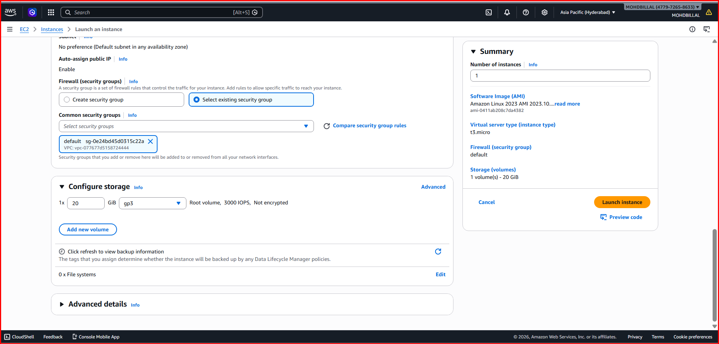

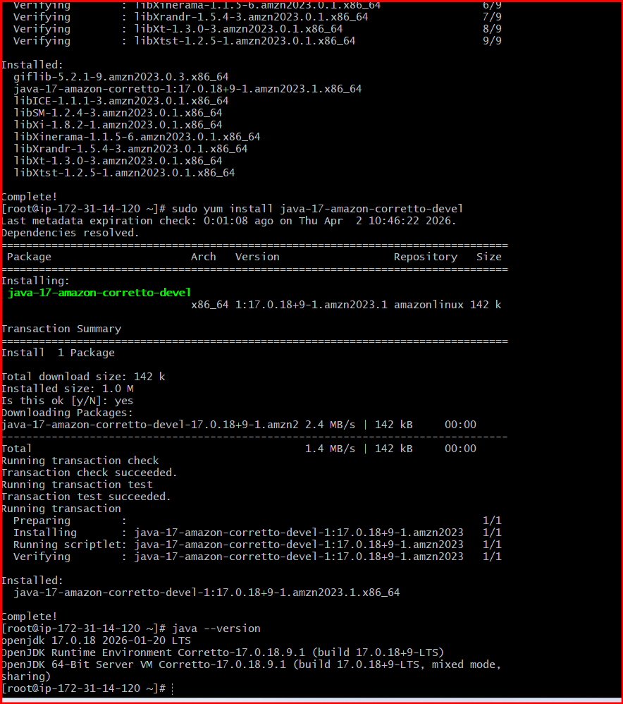
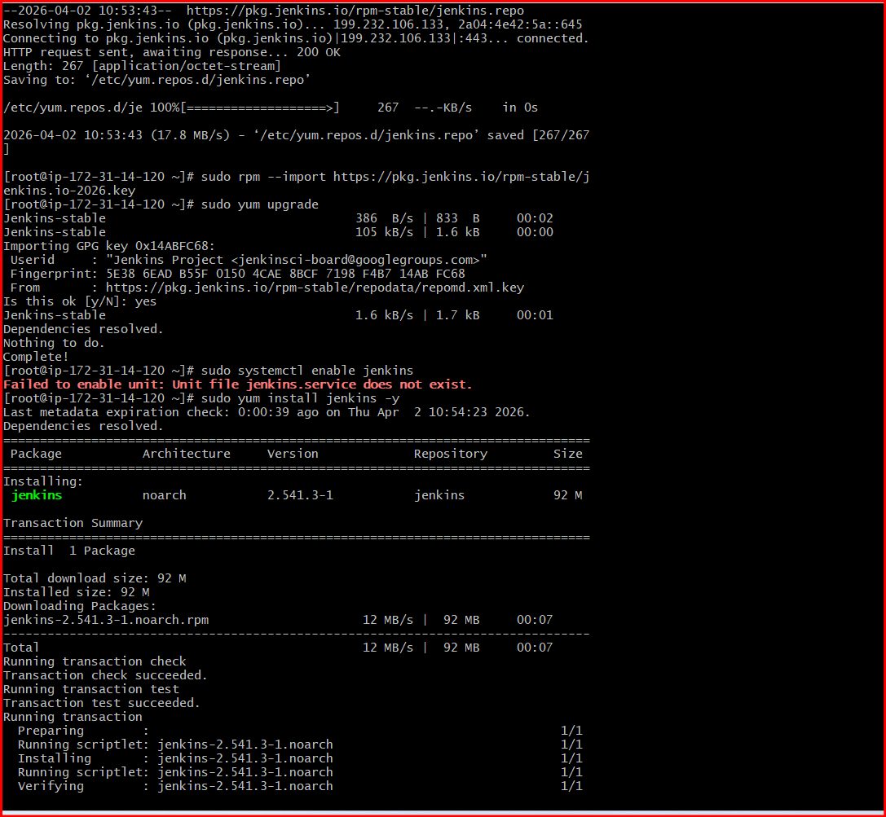

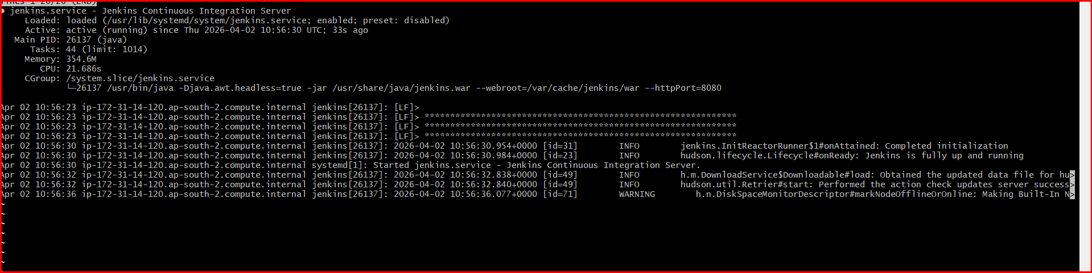
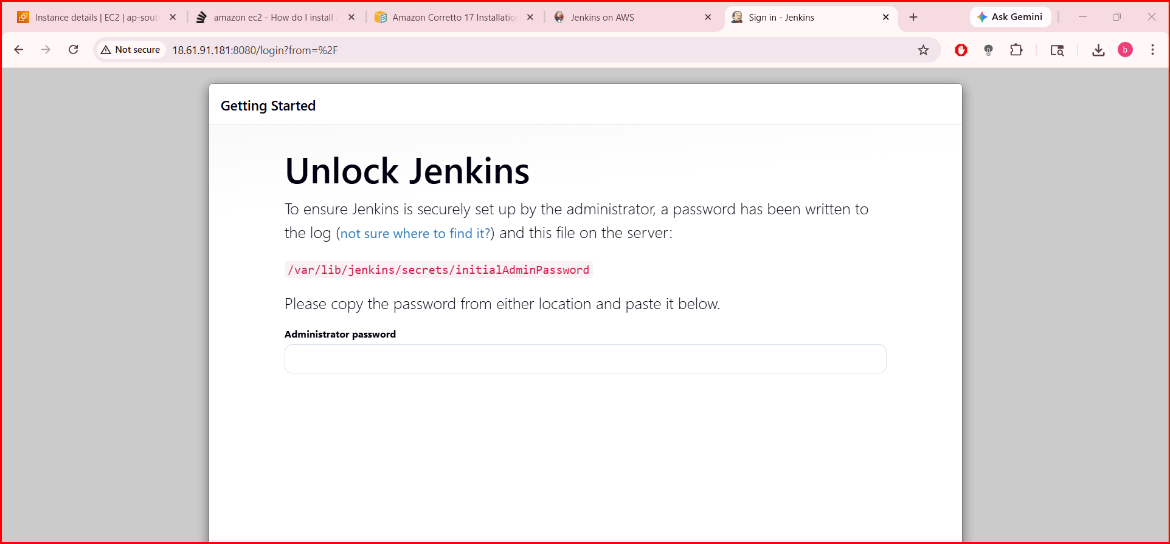
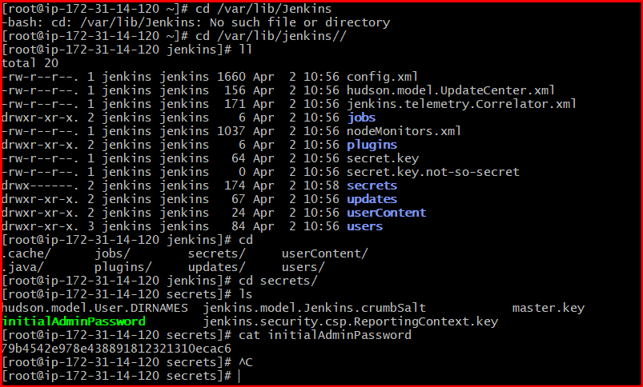
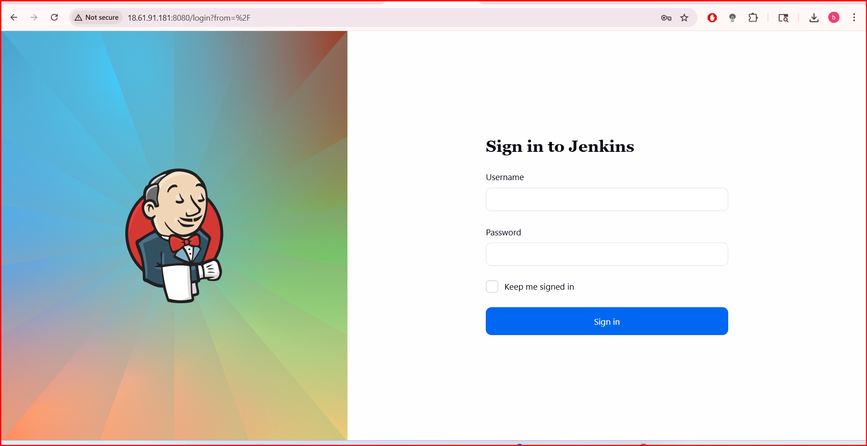
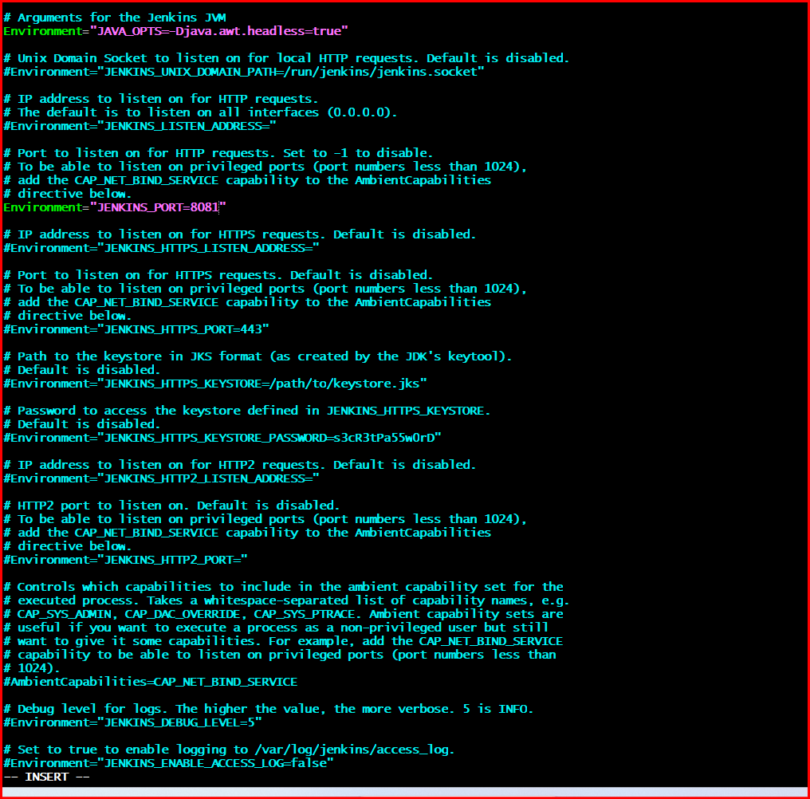
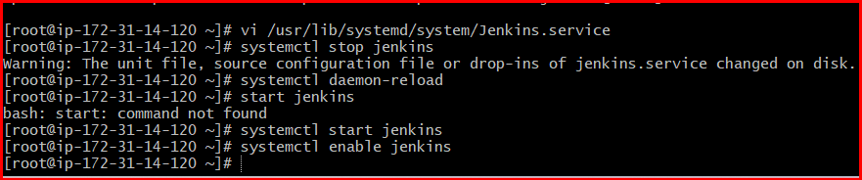
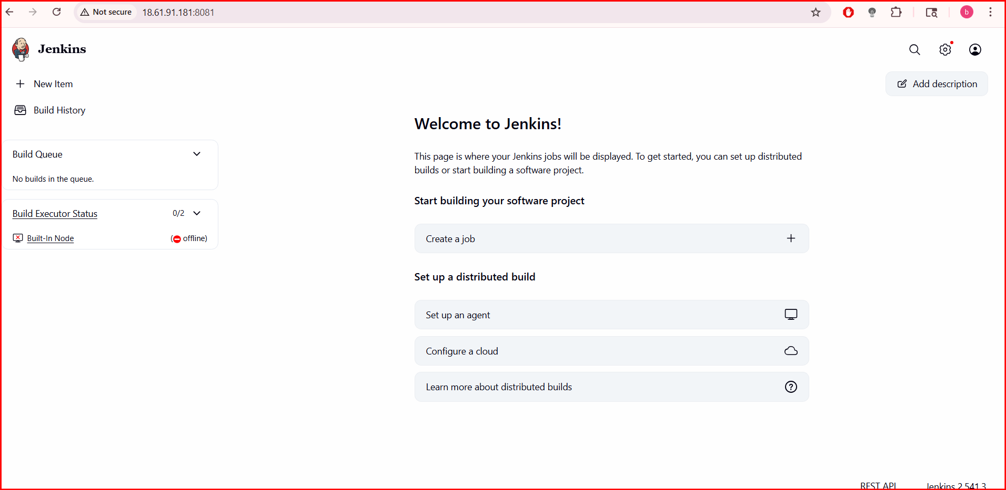
- Secure Jenkins server.
- Create users called DevOps, Testing in Jenkins with Limited access.

Step 1: Create Users
Go to:
👉 Manage Jenkins → Manage Users → Create User

Create User 1:
- Username: devops
- Password: (set strong password)
- Full Name: DevOps
- Click Create User

Create User 2:
- Username: testing
- Password: (set strong password)
- Full Name: Testing
- Click Create User

🔐 Step 2: Enable Authorization (Important)
Go to:
👉 Manage Jenkins → Configure Global Security

Set:
- ✔ Enable Security
- Security Realm → Jenkins’ own user database
- Authorization → Matrix-based security

🔑 Step 3: Assign Limited Permissions
Scroll to Authorization → Matrix-based security

Add Users:
- Add:
  - devops
  - testing

👨‍💻 DevOps User Permissions
Give DevOps build + job control access:
✔ Overall:
- Read
✔ Job:
- Read
- Build
- Configure
✔ View:
- Read
❌ Do NOT give:
- Administer

🧪 Testing User Permissions
Give Testing only limited access (read + build):
✔ Overall:
- Read
✔ Job:
- Read
- Build
✔ View:
- Read
❌ Do NOT give:
- Configure
- Administer

Admin (Your User)
Make sure your admin user has:
✔ All permissions (especially Administer)
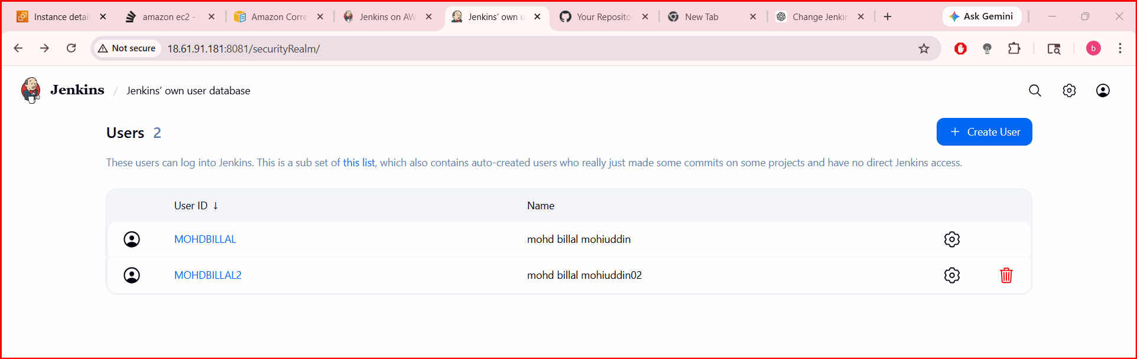
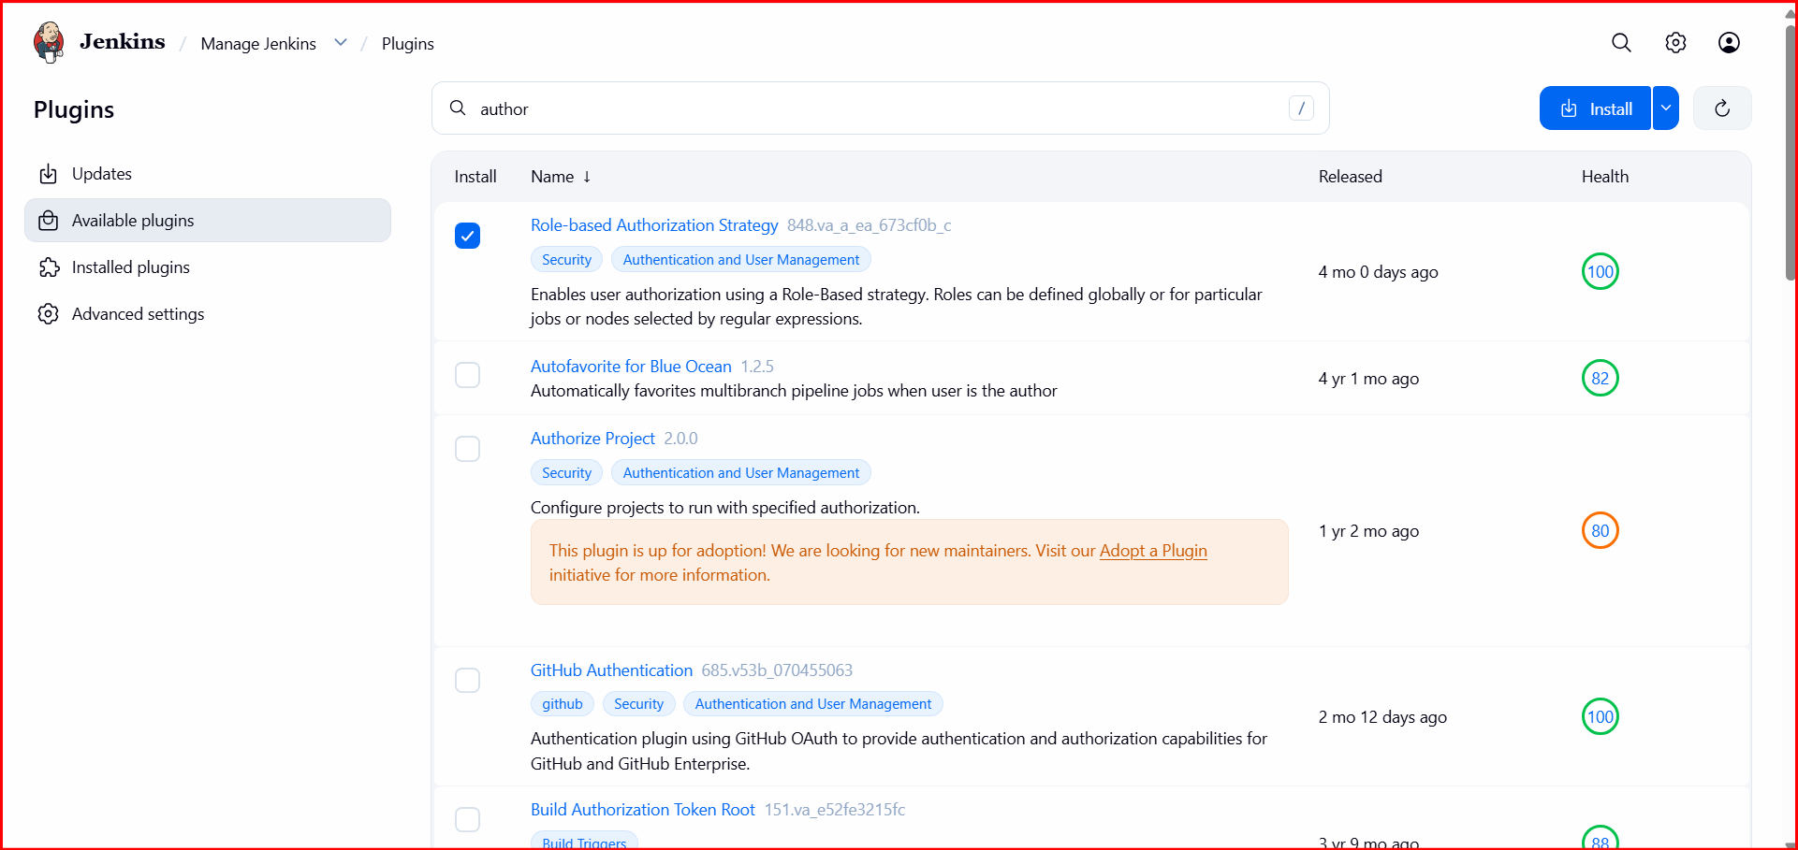
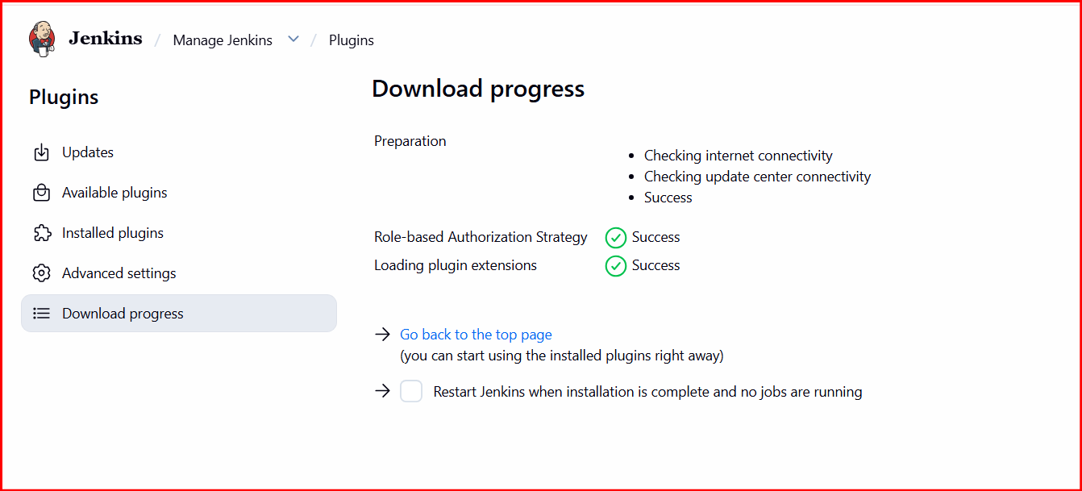
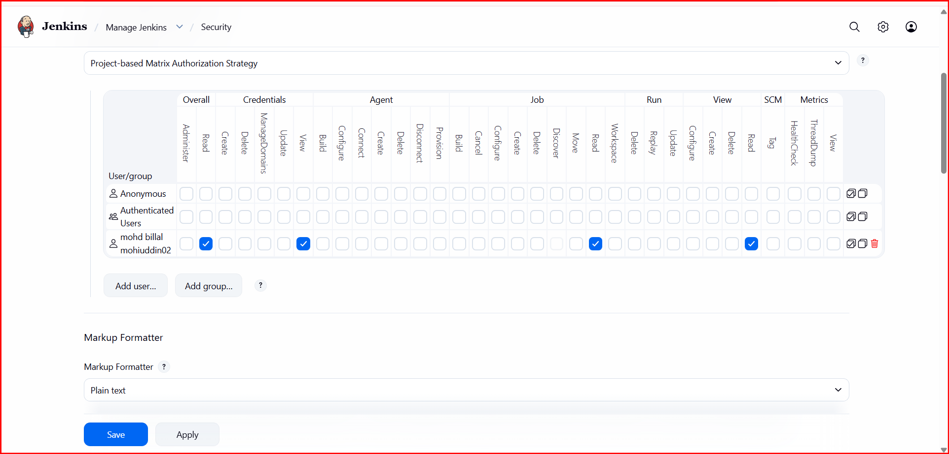
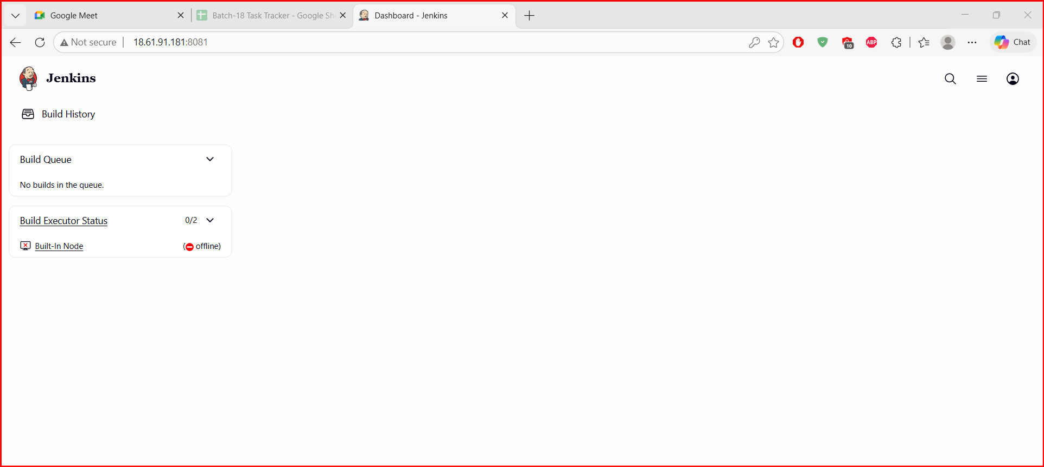
04: Configure labels and restrict the jobs to execute based on label only.

1. Add Label to Node (Agent)
Go to:
👉 Manage Jenkins → Manage Nodes and Clouds → Nodes

Select your node (agent)
Click:
👉 Configure

Find:
Labels
Example:
devops-node
OR
testing-node
👉 You can give multiple labels:
devops linux docker
Click Save

🧩 2. Configure Job to Use Label
Go to your job:
👉 New Item / Existing Job → Configure

Find:
✔ Restrict where this project can be run
👉 Enable it

In Label Expression:
Enter:
devops-node
OR
testing-node
Click Save

⚙️ 3. How It Works
- Jenkins will only run the job on nodes matching the label
- If no node matches → job will be queued (not executed)

🔐 4. Restrict Jobs Based on User (Optional but Recommended)
Combine labels with your users:

Example setup:
User | Label | Node
DevOps | devops-node | DevOps Agent
Testing | testing-node | Testing Agent

🧪 5. Example

Node 1:
- Name: node1
- Label: devops-node

Node 2:
- Name: node2
- Label: testing-node

Job A (DevOps Job):
- Restrict → devops-node
👉 Runs only on DevOps node

Job B (Testing Job):
- Restrict → testing-node
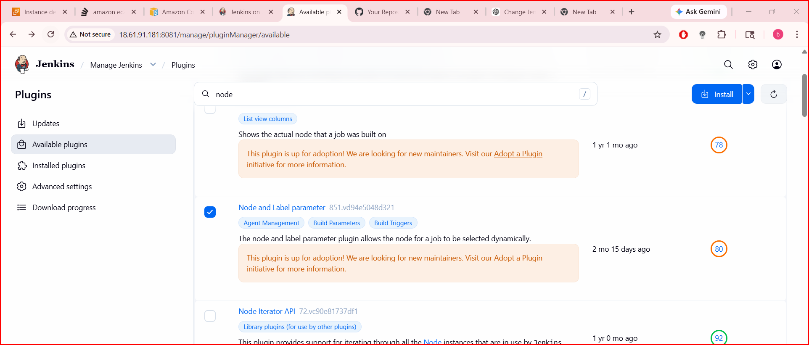

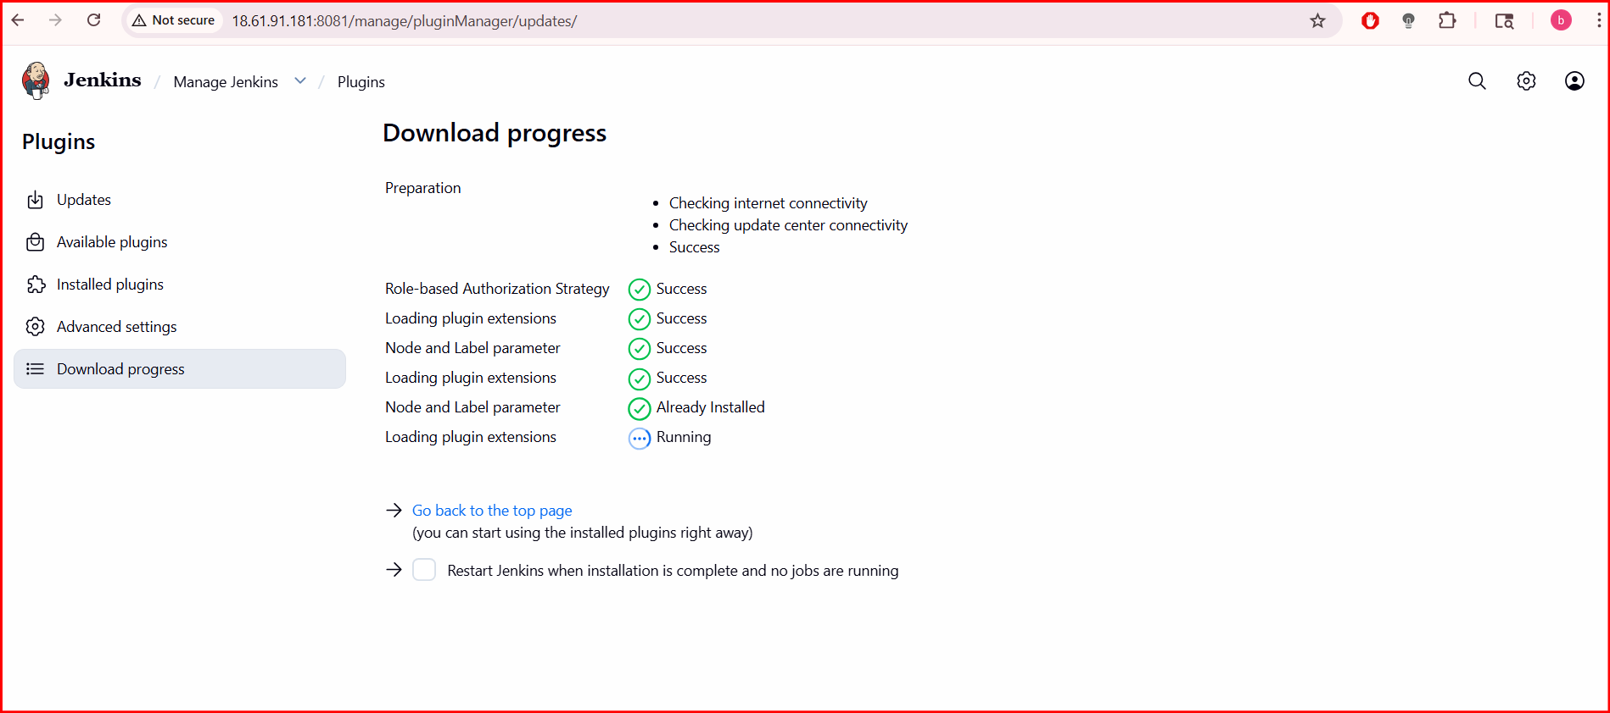

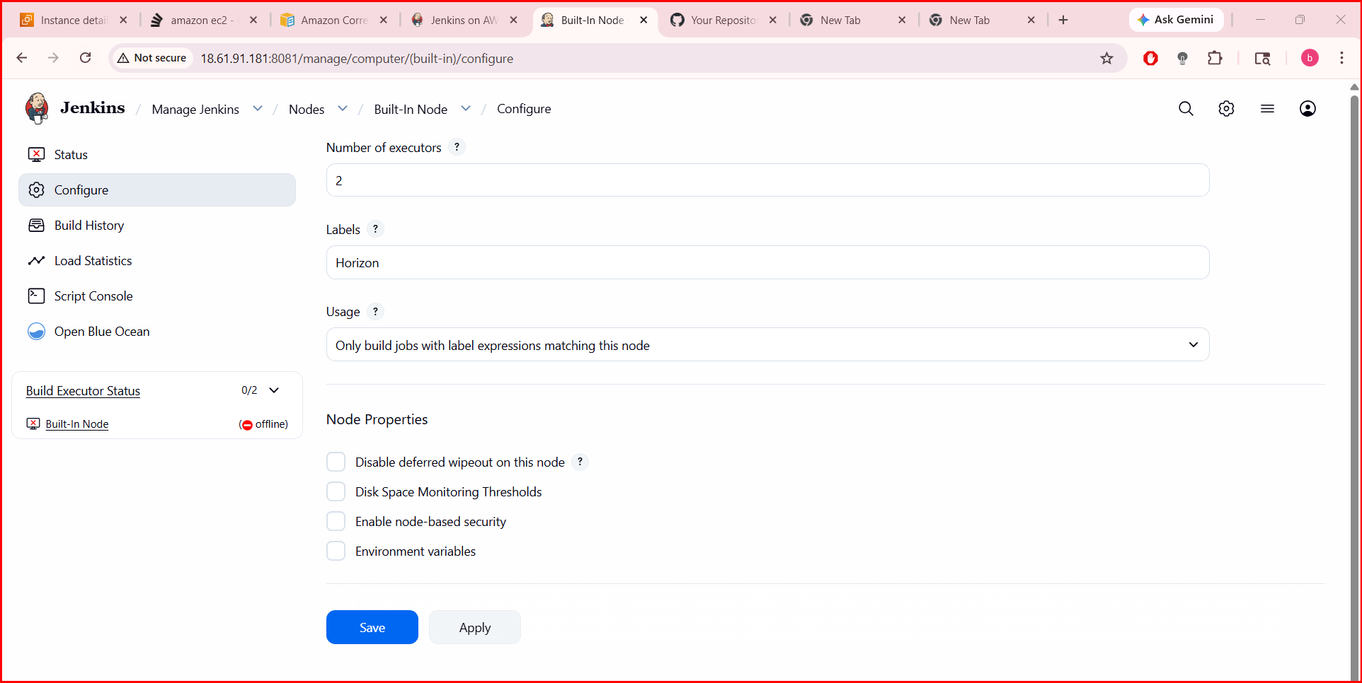

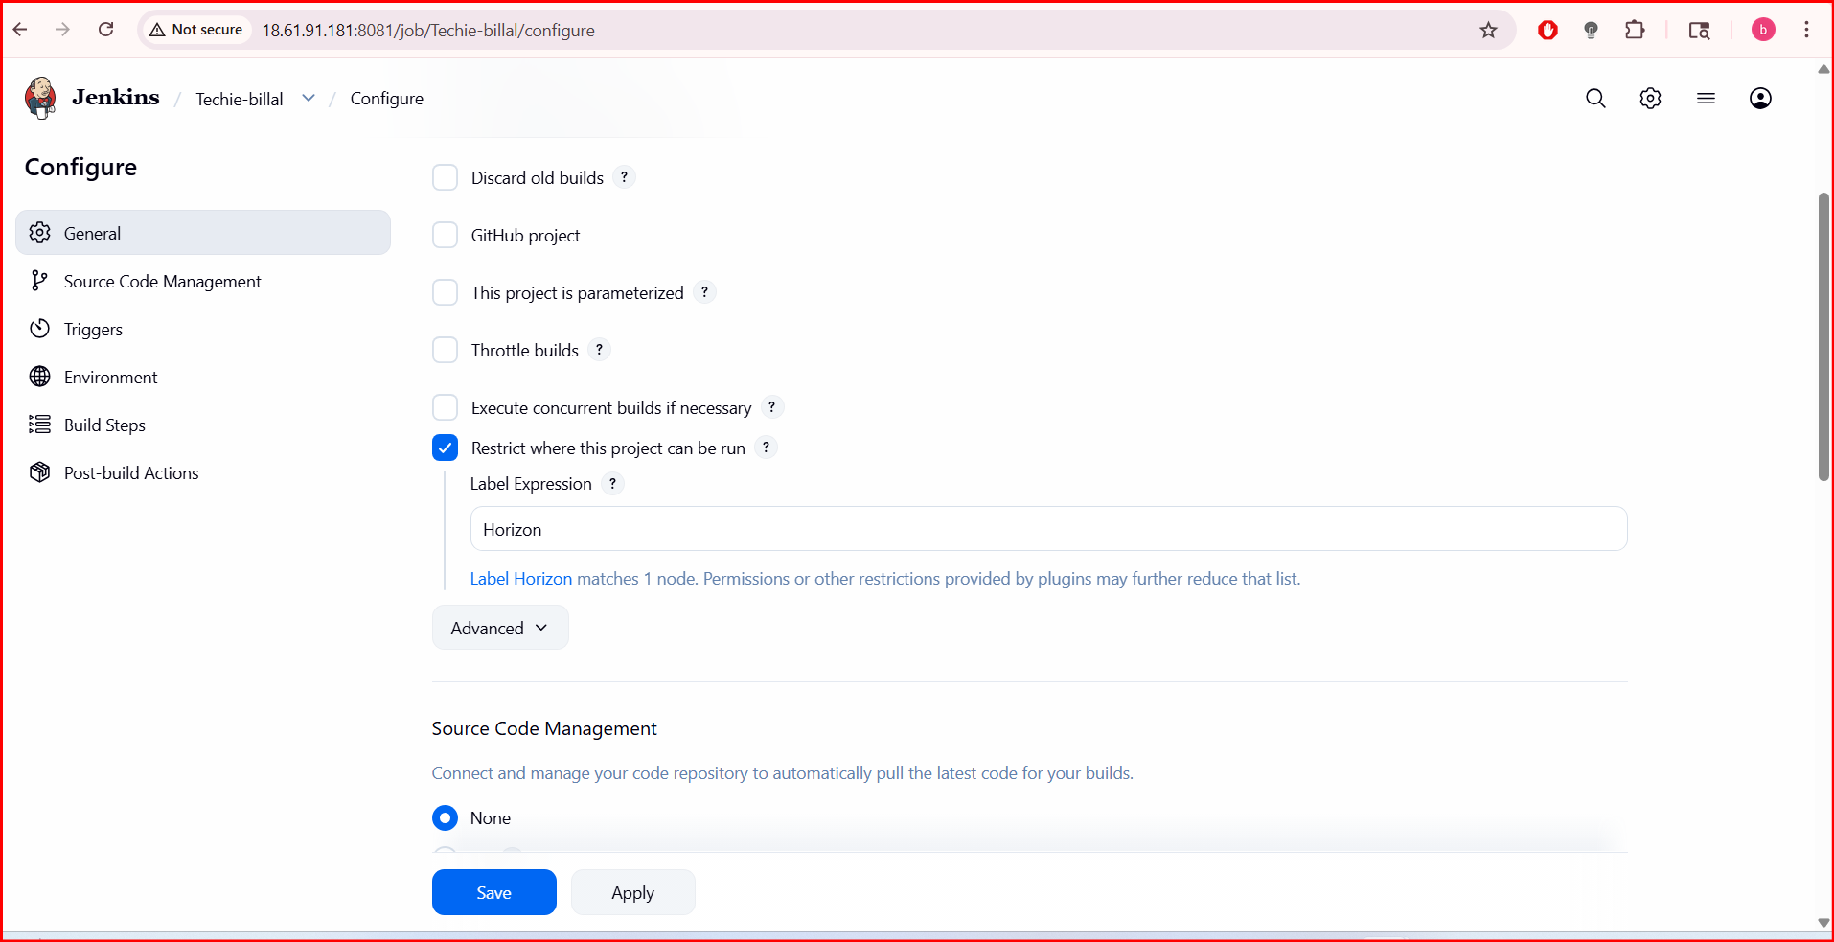

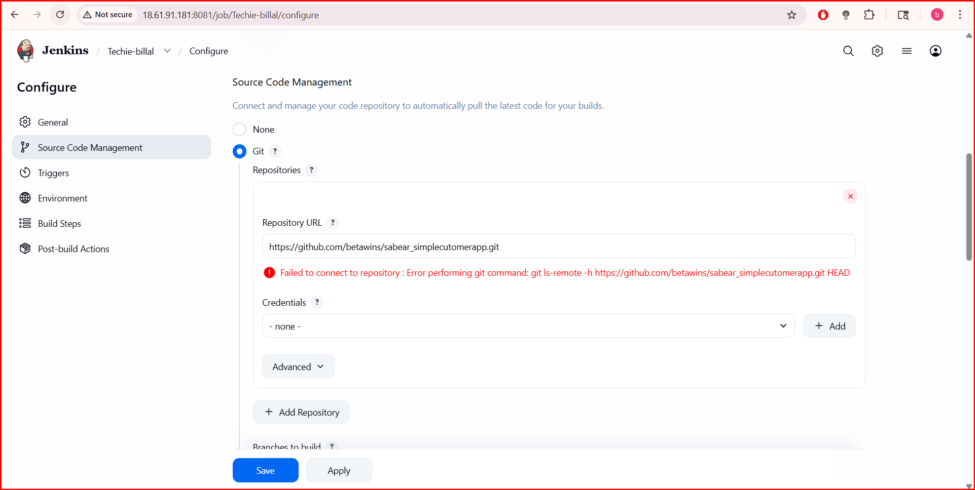
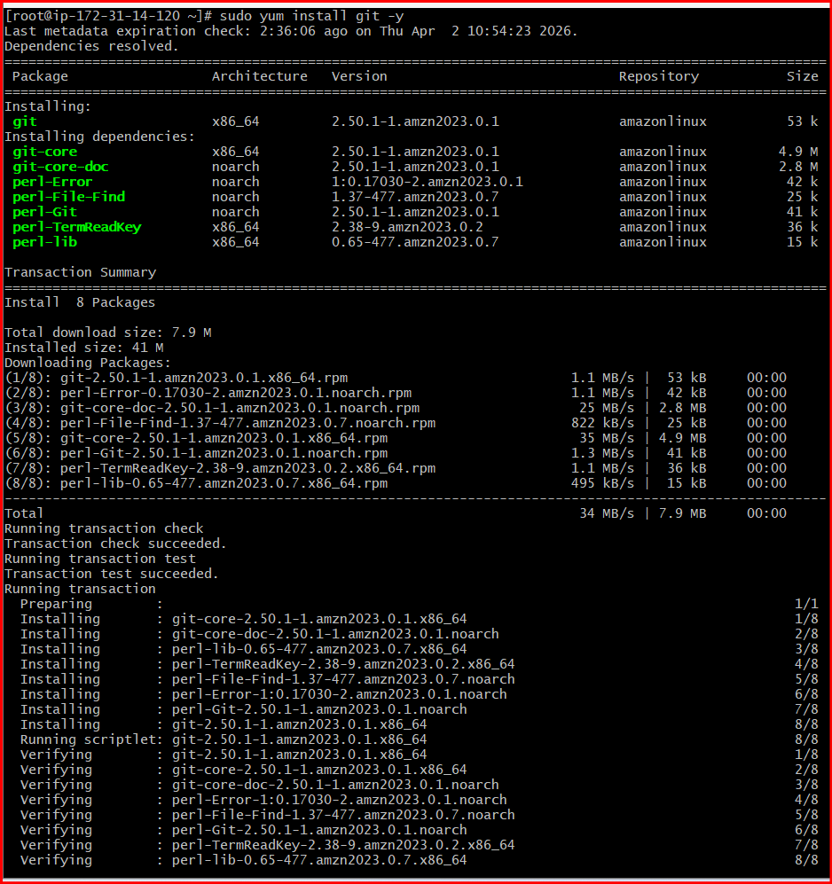
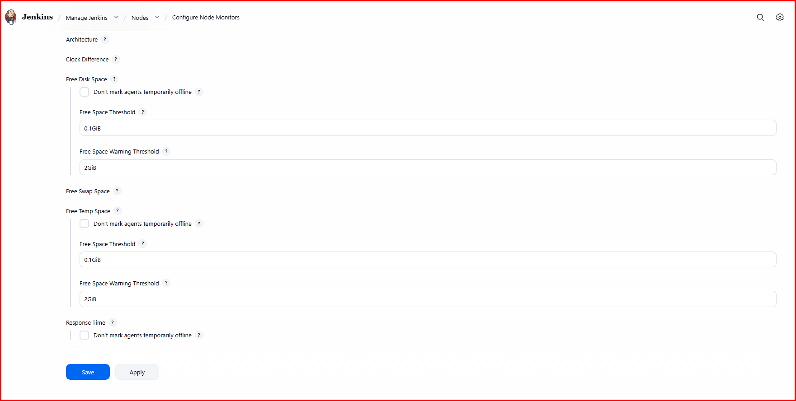
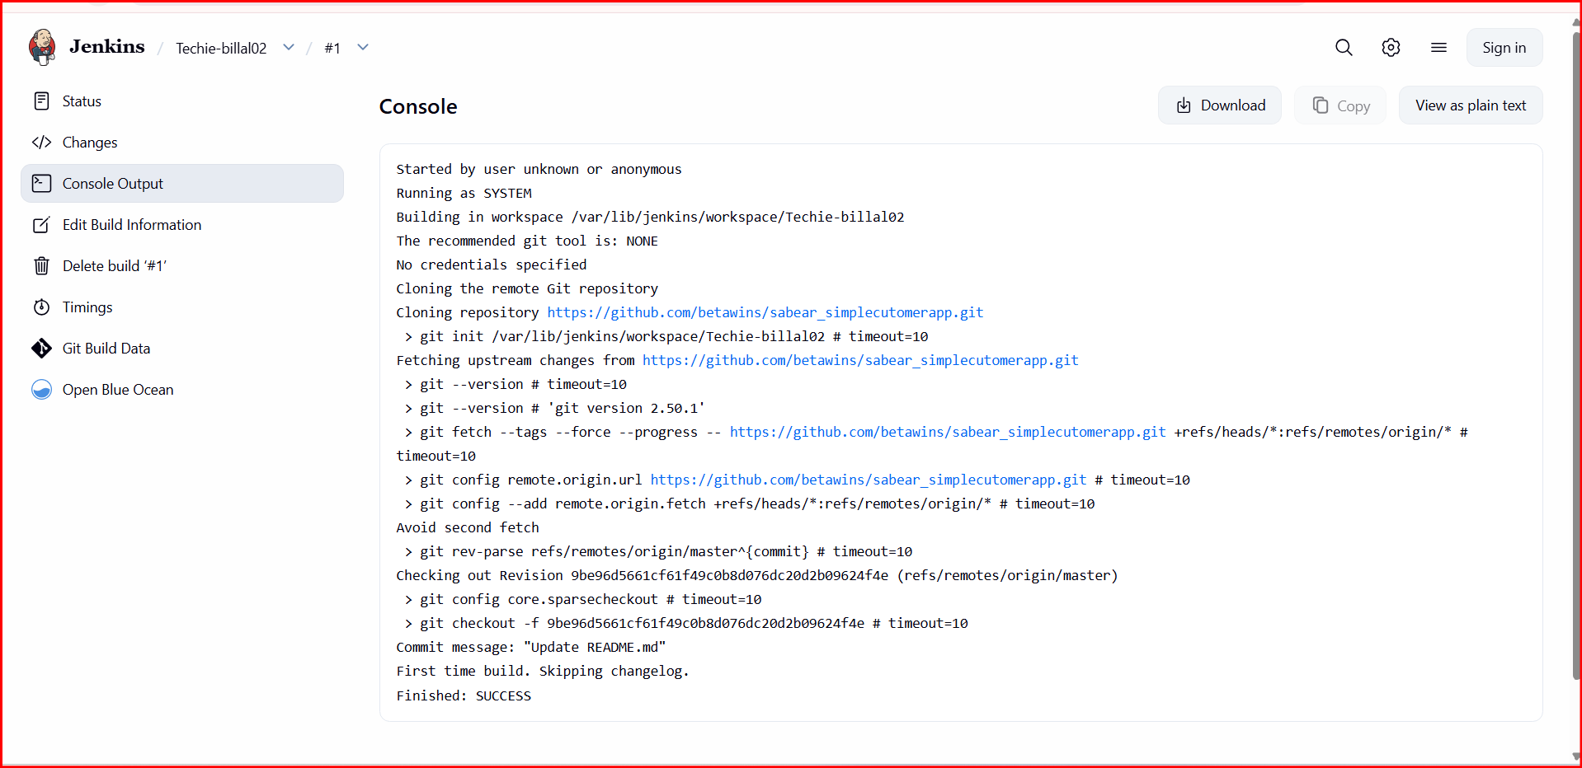
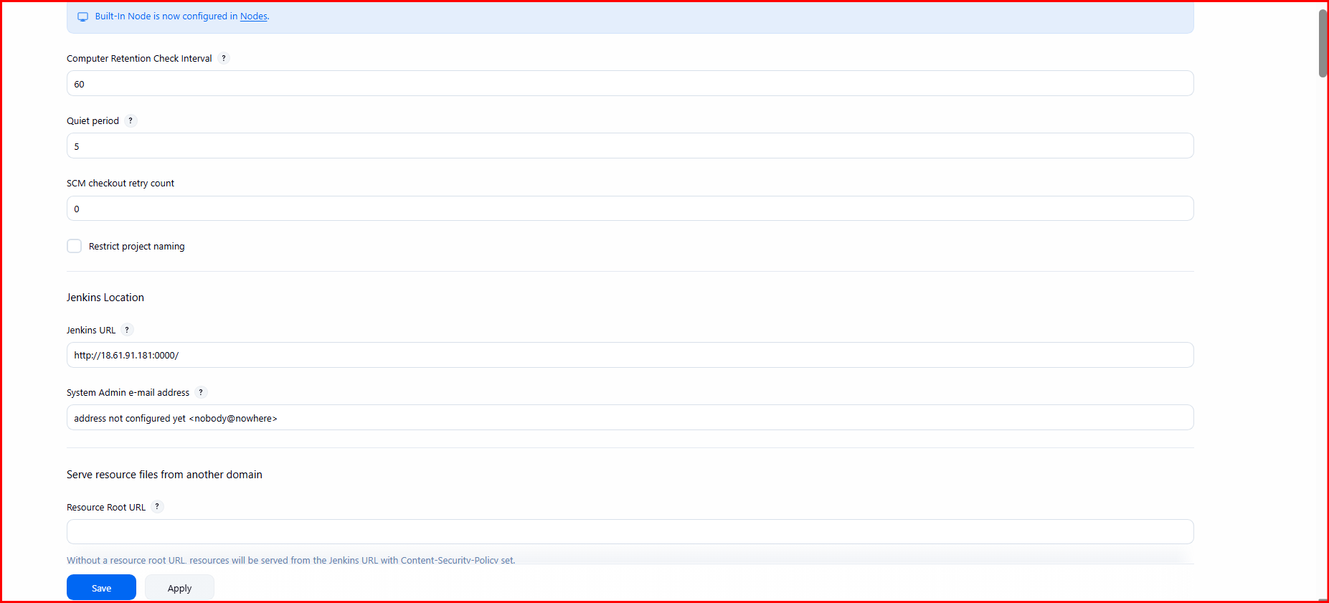
05: Create Three sample jobs using the below URL.

Create Job 1 (Build Job)
Go to:
👉 Jenkins Dashboard → New Item

Configure:
- Name: Job-1-Build
- Type: Freestyle Project
- Click OK

Source Code Management:
- Select Git
- Enter your repo URL:
https://github.com/your-username/your-repo.git

Build Step:
- Click Add build step → Execute shell
echo "This is Build Job"
Click Save

🚀 3. Create Job 2 (Test Job)
👉 New Item

Configure:
- Name: Job-2-Test
- Type: Freestyle Project

Source Code Management:
(Same Git URL)

Build Step:
echo "Running Test Job"
Click Save

🚀 4. Create Job 3 (Deploy Job)
👉 New Item

Configure:
- Name: Job-3-Deploy
- Type: Freestyle Project

Source Code Management:
(Same Git URL)

Build Step:
echo "Deploying Application"
Click Save

🔗 5. (Optional) Chain Jobs Together
To run jobs in sequence:

In Job-1:
- Go to Post-build Actions
- Select:
👉 Build other projects
Job-2-Test

In Job-2:
- Add:
Job-3-Deploy
👉 Now flow:
Build → Test → Deploy
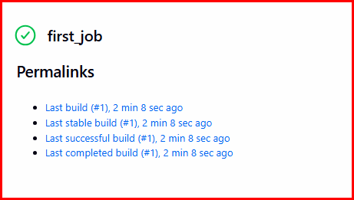
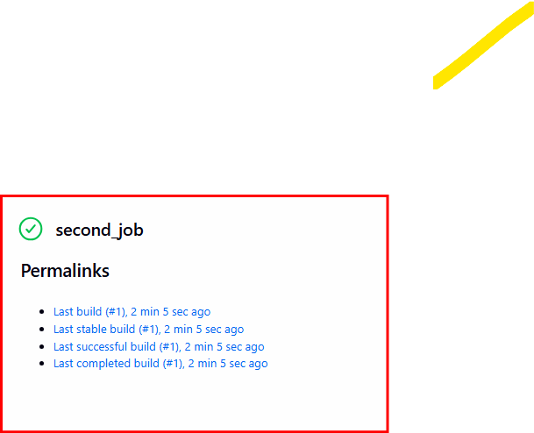
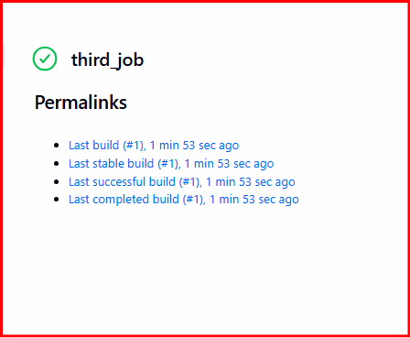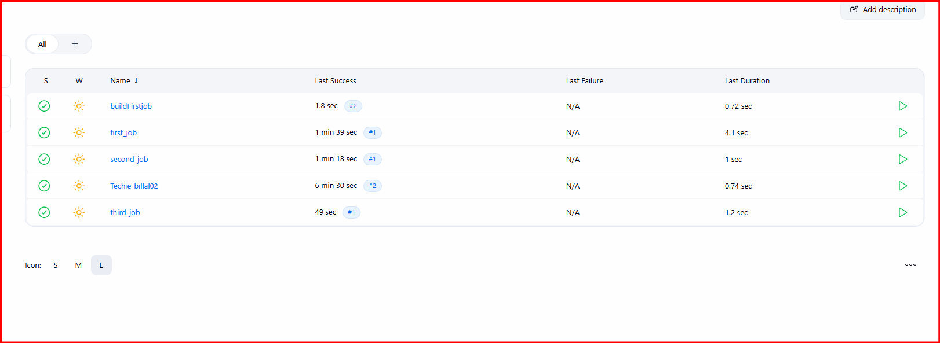
07: Create one Jenkins job using GitHub Private repository.

Step 1: Generate GitHub Token
Go to:
👉 GitHub → Settings → Developer Settings → Personal Access Tokens → Tokens (classic)
Click:
👉 Generate new token

Select scopes:
✔ repo (Full control of private repositories)
Copy the token (example):
ghp_xxxxxxxxxxxxxxxxx

🔹 Step 2: Add Credentials in Jenkins
Go to:
👉 Manage Jenkins → Manage Credentials → Global → Add Credentials

Fill:
- Kind: Username with password
- Username: your GitHub username
- Password: Paste token (NOT your GitHub password)
- ID: github-creds (any name)
Click OK

🔹 Step 3: Create Jenkins Job
👉 New Item → Freestyle Project

Configure:

Source Code Management:
- Select Git
- Repository URL:
https://github.com/your-username/your-private-repo.git
- Credentials:
👉 Select github-creds

🔹 Step 4: Add Build Step
echo "Cloning Private Repo Successful"
Click Save

🔹 Step 5: Build Job
👉 Click Build Now
✔ If configured correctly → build will succeed

